Assignment -1

1.
<html>
<head>
<title>Sum of numbers</title>
</head>
<body>
<script>
var number = parseInt(prompt('Enter a Positive integer: '));

var sum = 0;
for (i = 1; i <= number; i++) {
sum += i;
}
</script>
</body>
</html>

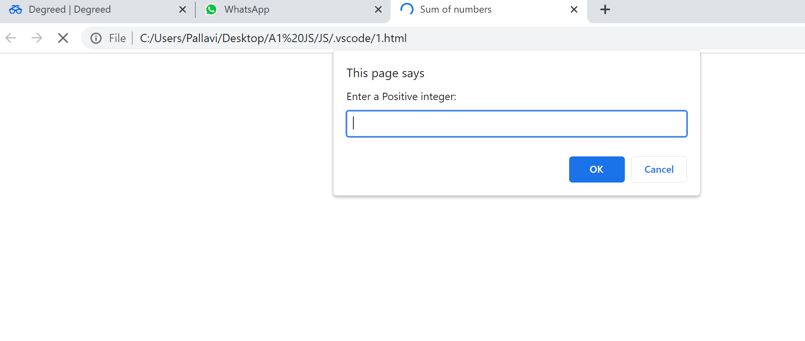

2.
<html>
<head>
<title>Sum of N 3,5 multiples</title>
</head>
<body>
<script>
var number = 17

var sum = 0;
document.write('The sum of natural numbers for n = ',number,' : ');
for (i = 1; i <= number; i++) {
sum += i;
if(sum % 3 == 0 || sum % 5 == 0)
document.write(sum," ");
}
</script>
</body>
</html>

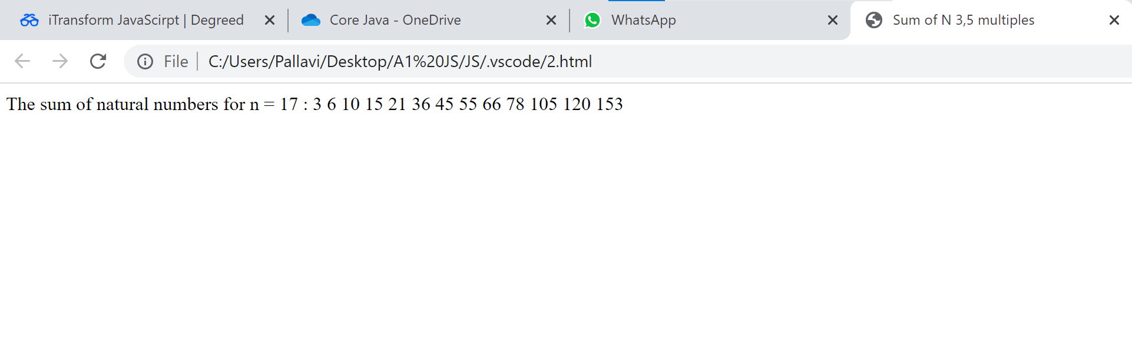
3.

<html>
<head>
<title>Even Odd Parity check</title>
</head>
<body>
<script>
var number = parseInt(prompt('Enter a positive integer: '));
evenOdd(number);

function evenOdd(number){
if(number % 2 == 0)
document.write('parity(',number,') "even"');
else
document.write('parity(',number,') "odd"');
}
</script>
</body>
</html>

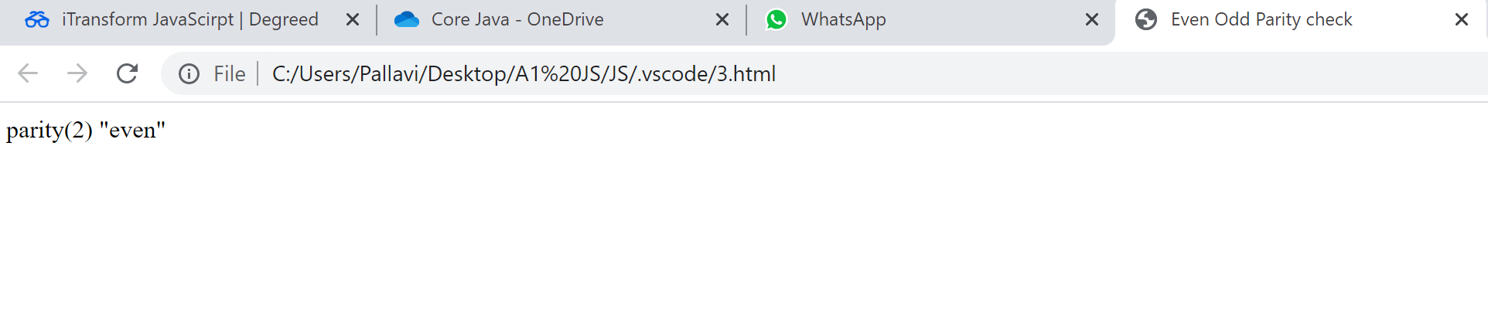
4.
<html>
<head>
<title>Probability </title>
</head>
<body>
<script>
var flip = parseInt(prompt('Enter the no. of flips: '));
document.write(flipProbability(flip));

function flipProbability(flips){
var sumHeads =0;
for(i=0; i<flips;i++){
var toss = Math.random() * 1;
document.writeln(toss,": toss<br>");
if(Math.floor(toss) == 1)
sumHeads+=1;
}
return sumHeads/10;
}
</script>
</body>
</html>
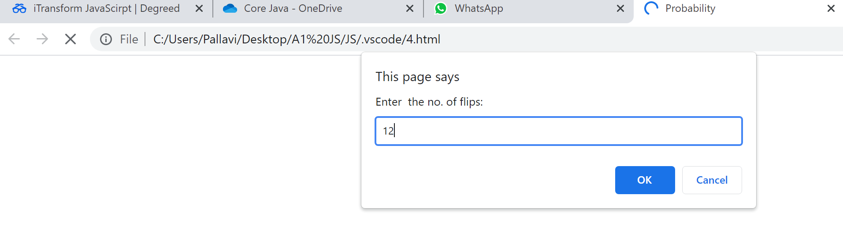
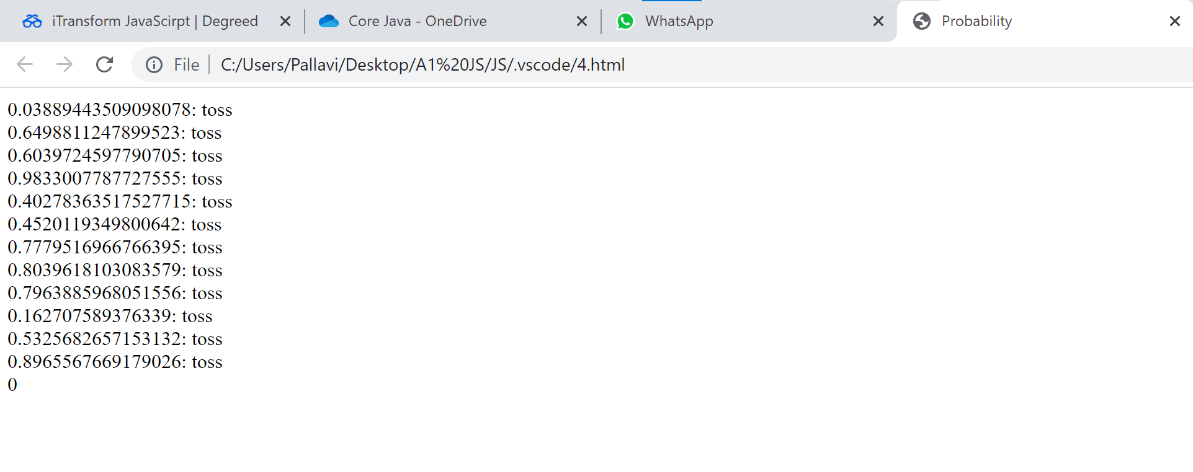
5.
<html>
<head>
<title>Sum </title>
</head>
<body>
<script>
var year = parseInt(prompt('Enter the year'));
var count = 0;
document.write("20 leap years from ",year," are: ");
while (count < 20) {
if (year % 4 == 0) {
if (year % 100 != 0 || year % 400 == 0) {
++count;
document.write(year," ");
}
}
++year;
}
</script>
</body>
</html>

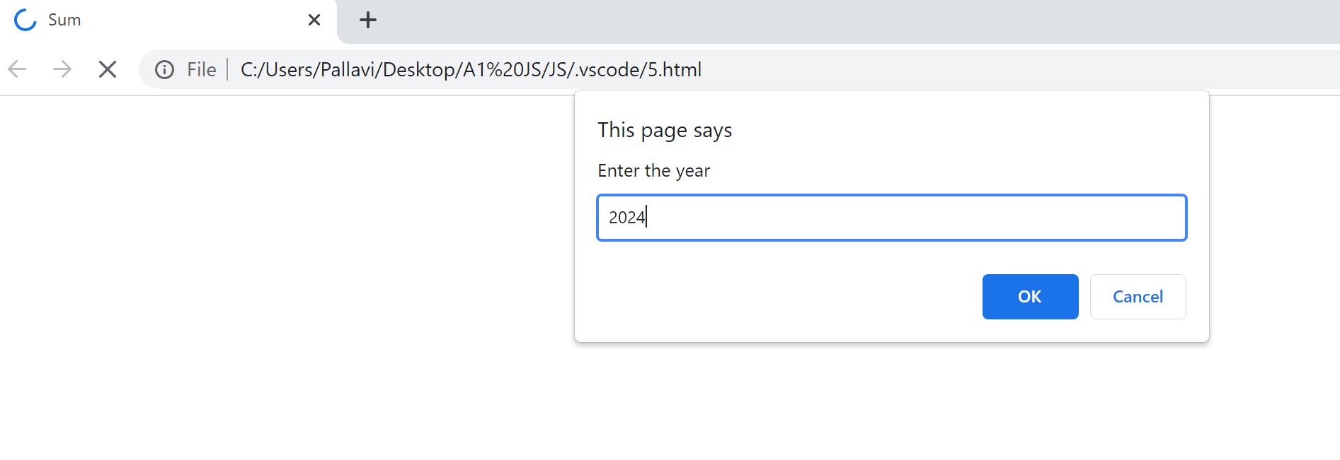
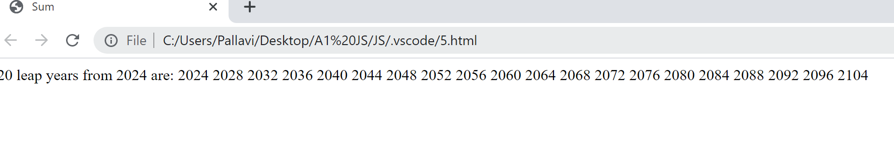

6.
<html>
<head>
<title> Frame</title>
</head>
<body>
<script>
var flip = prompt('Enter the array ');
var array = flip.split(" ");
//document.write("array: ",array);
document.write("*************<br>");
for(i=0;i<array.length;i++){
document.write("*",array[i],"*<br>");
}
document.write("*************");
</script>
</body>
</html>
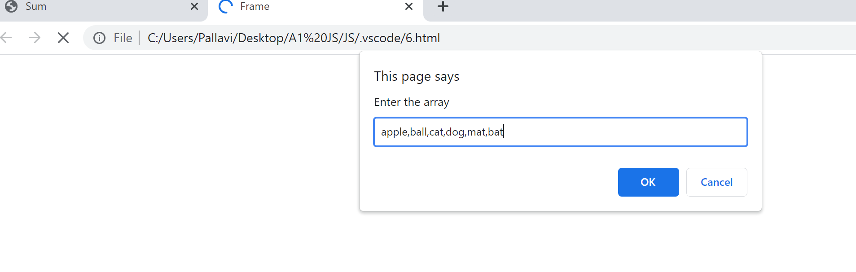
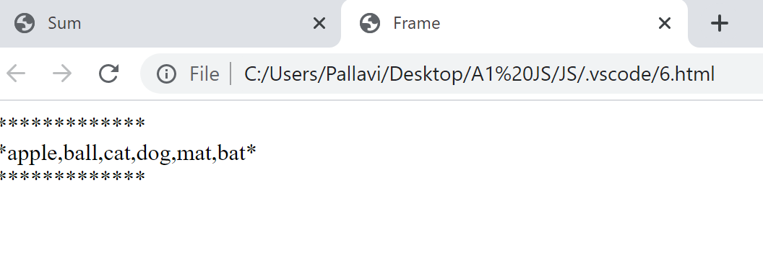

7.
<html>
<head>
<title>Currency </title>
</head>
<body>
<script>
var dollar = parseInt(prompt('Enter amount in dollar'));
document.writeln(dollar,"dollar in other currencies: <br>");
var rupee = dollar*74.20;
var euro = dollar*0.85;
var yen = dollar*109.841;
document.writeln(rupee,"Rs is ",dollar,"$ <br>");
document.writeln(euro,"Pound is ",dollar,"$.<br>");
document.writeln(Math.round(yen),"Yen is ",dollar,"$.<br>");
</script>
</body>
</html>
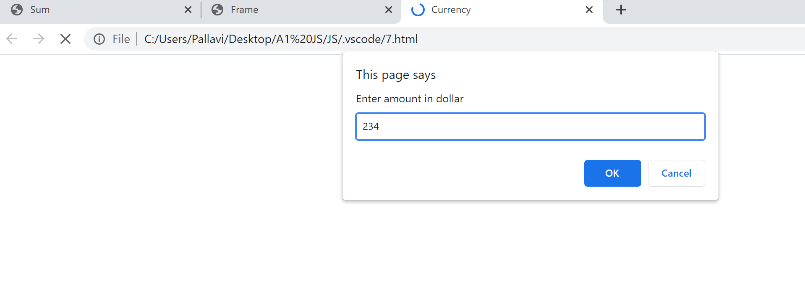
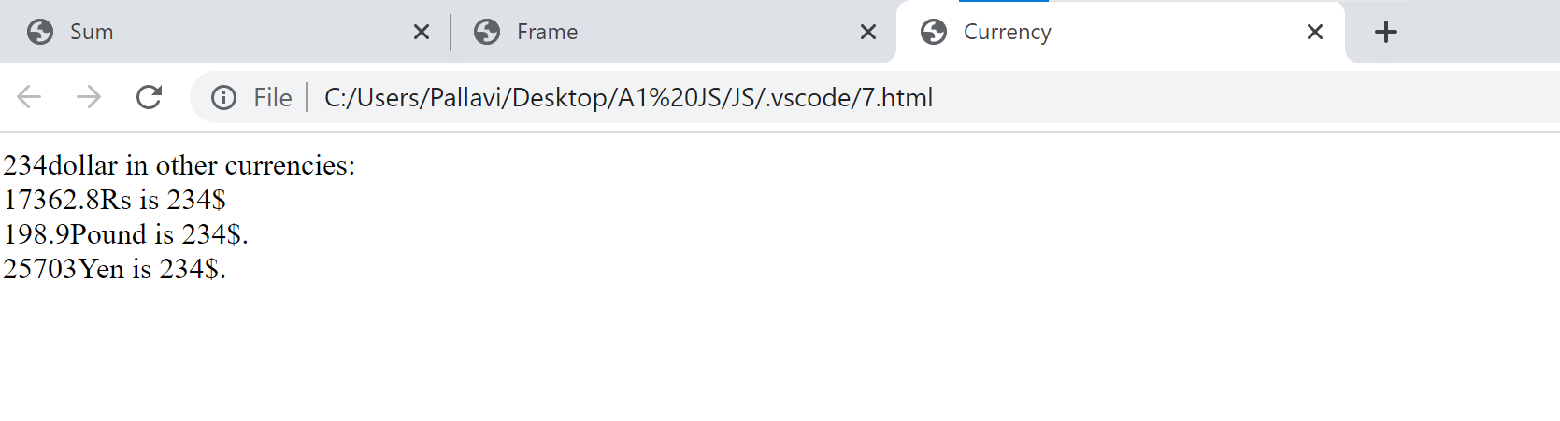
8.
<html>
<head>
<title>alt arrays</title>
</head>
<body>
<script>
var array1 = prompt(" string1 ");
array1 = array1.split(" ");
document.writeln("array1: ",array1.toString(),"<br>");
var array2 = prompt(" string2 ");
array2 = array2.split(" ");
document.writeln("array2: ",array2.toString(),"<br>");
var newarr = concat(array1,array2);
document.writeln("merged array: ",newarr.toString());

function concat(a,b){
return a.concat(b);
}
</script>
</body>
</html>
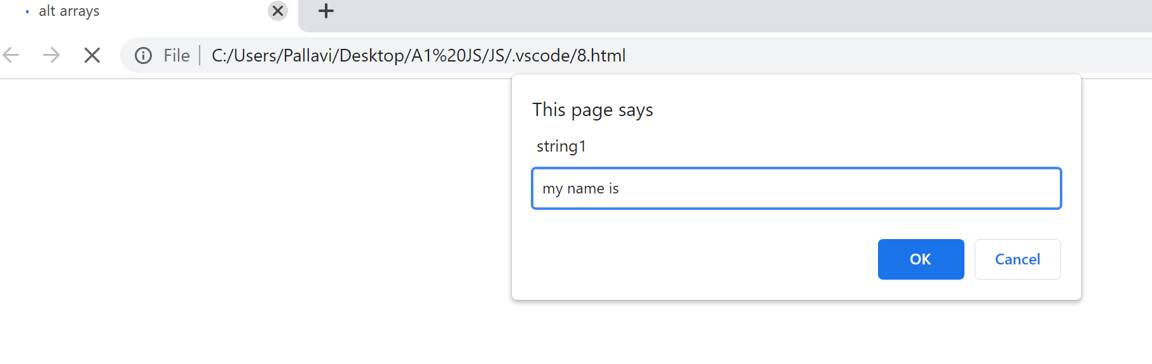
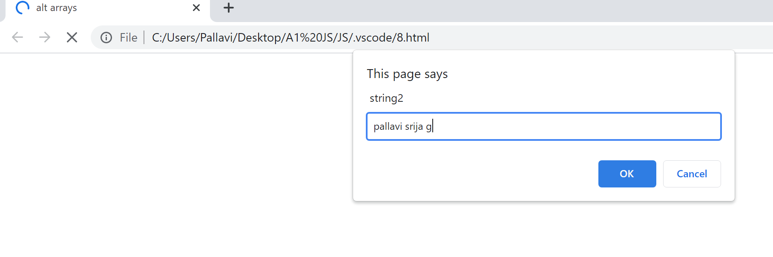
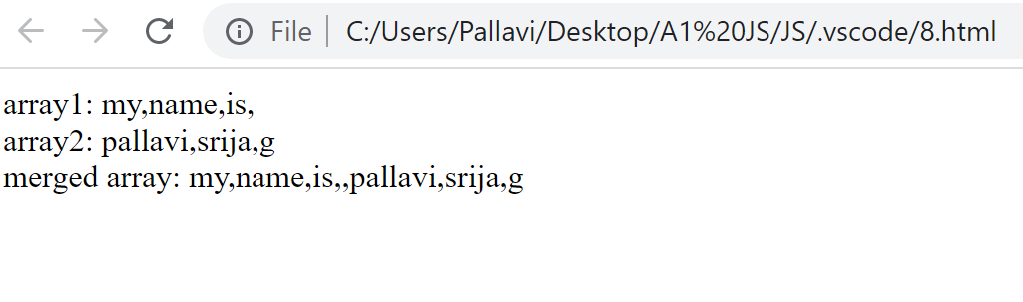
9.
<html>
<head>
<title>Array</title>
</head>
<body>
<script>
var array1 = ["bat","cat","mat"];
var array2 = [11,22,33];
var newarr = merge(array1,array2);
document.writeln("merged array: ",newarr);

function merge(a,b){
let l = a.length+b.length;
let r = [];
let j=0,k=0;
for(let i=0; i<l;i++) {
if(i%2==0) {
r[i]=a[j++];
} else {
r[i]=b[k++];
}
}
return r;
}
</script>
</body>
</html>
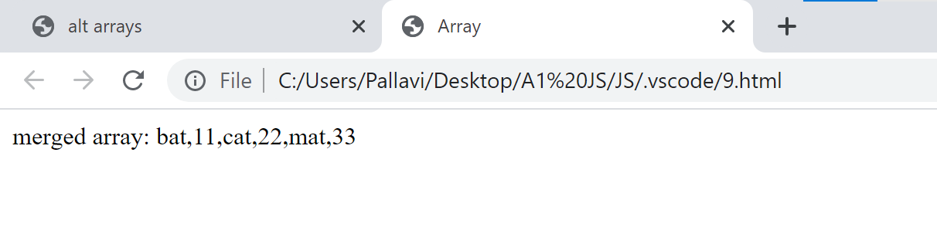
10.
<html>
<head>
<title>Fib no.'s</title>
</head>
<body>
<script>
let n1 = 0, n2 = 1, nextTerm;

document.writeln('Fibonacci Series:<br>');

for (let i = 1; i <= 100; i++) {
document.writeln(n1,", ");
nextTerm = n1 + n2;
n1 = n2;
n2 = nextTerm;
}
</script>
</body>
</html>

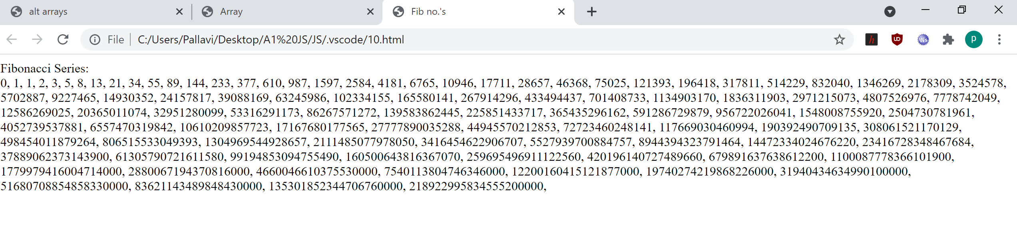
11.
<html>
<head>
<title>reversing array</title>
</head>
<body>

<script>
var arr = [123, 987, 788, 999];
for(let i = 0; i < arr.length; i++){
console.log(arr[i]);
}
var new_arr = arr.reverse();
for(let i = 0; i < arr.length; i++){
console.log(arr[i]);
}
</script>
</body>
</html>

12.
<html>
<head>
<title>sequence</title>
</head>
<body>
<script>
var string = prompt("Enter continuous single string");
var output ="", temp = "";
document.write(string," type: ",typeof(string));
for(i=0;i<string.length;i++){
if(string.charAt(i) == "a" || string.charAt(i) == "b" ){
//document.write("before temp ",i," : ",temp," output : ",output,"<br>");
if(temp.length> output.length)
output = temp;
temp = "";
//document.write("after temp ",i," : ",temp," output : ",output,"<br><br>");
}
else{
temp = temp.concat(string.charAt(i));
//document.write(" temp ",i," : ",temp," output : ",output,"<br>");
}
}
document.write('final output: "',output,'"');
</script>
</body>
</html>

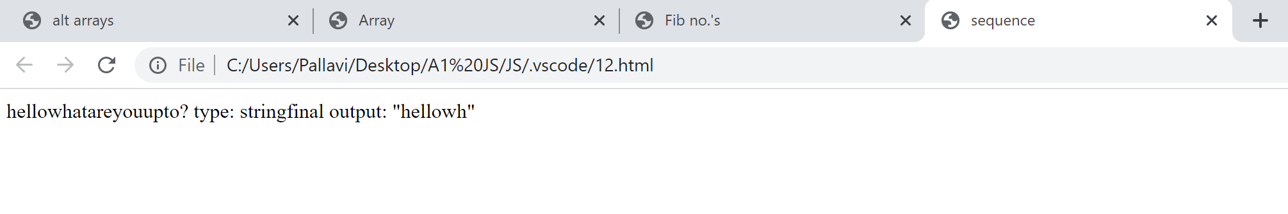
13.
<html>
<head>
<title>Sum of N numbers</title>
</head>
<body>
<script>
var number =prompt('Enter multiple integer string: ');
number = number.split(" ");
var array = new Array();
for (i = 0; i < number.length; i++) {
array[i] = parseInt(number[i]);
}

var sum = 0, i =0;

document.write("Sum of : <br> For Loop: ",For(sum, i,array));
document.write("<br> While Loop: ",While(sum, i,array));
document.write("<br> Do While Loop: ",DoWhile(sum, i,array));

function For(sum, i, array){
for (i; i < array.length; i++) {
sum += array[i];
}
return sum;
}

function While(sum, i, array){
while(i<array.length){
sum += array[i];
i++;
}
return sum;
}

function DoWhile(sum, i, array){
do{
sum += array[i];
i++;
}while(i<array.length)
return sum;
}

</script>
</body>
</html>

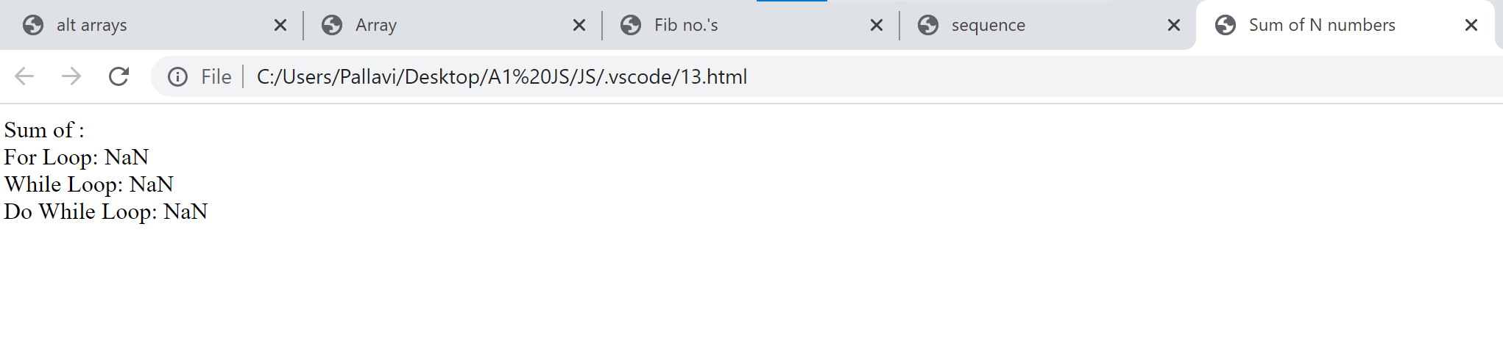
14.
<html>
<head>
<title>Sum of N numbers</title>
</head>
<body>
<script>
document.write("Array of random numbers");
var array = new Array();
for (i = 0; i < 100; i++) {
array[i] = Math.floor((Math.random() * 1000) + 1);
}
document.write("<br>Array: ",array.toString());
document.write("<br>Max of array: ",Max(array));
document.write("<br>Min of array: ",Min(array));
document.write("<br>Even or Odd: ",Count(array));
document.write("<br>Sum: ",Sum_Avg(array)[0]," and Average: ",Sum_Avg(array)[1]);

function Max(array){
var max = 0;
for (i=0; i < array.length; i++) {
max = ( max > array[i] ? max : array[i]);
}
return max;
}

function Min(array){
var max = 1000;
for (i=0; i < array.length; i++) {
max = ( max < array[i] ? max : array[i]);
}
return max;
}
function Count(array){
var even = 0, odd = 0;
for (i=0; i < array.length; i++) {
if(array[i] % 2 == 0)
even++;
else
odd++;
}
return (even>odd?"Even!":"Odd!");
}
function Sum_Avg(array){
var sum = 0, avg =0, SumAvg = [];
for (i=0; i < array.length; i++) {
sum += array[i];
}
SumAvg = [sum, sum/100] ;
return SumAvg;
}
</script>
</body>
</html>
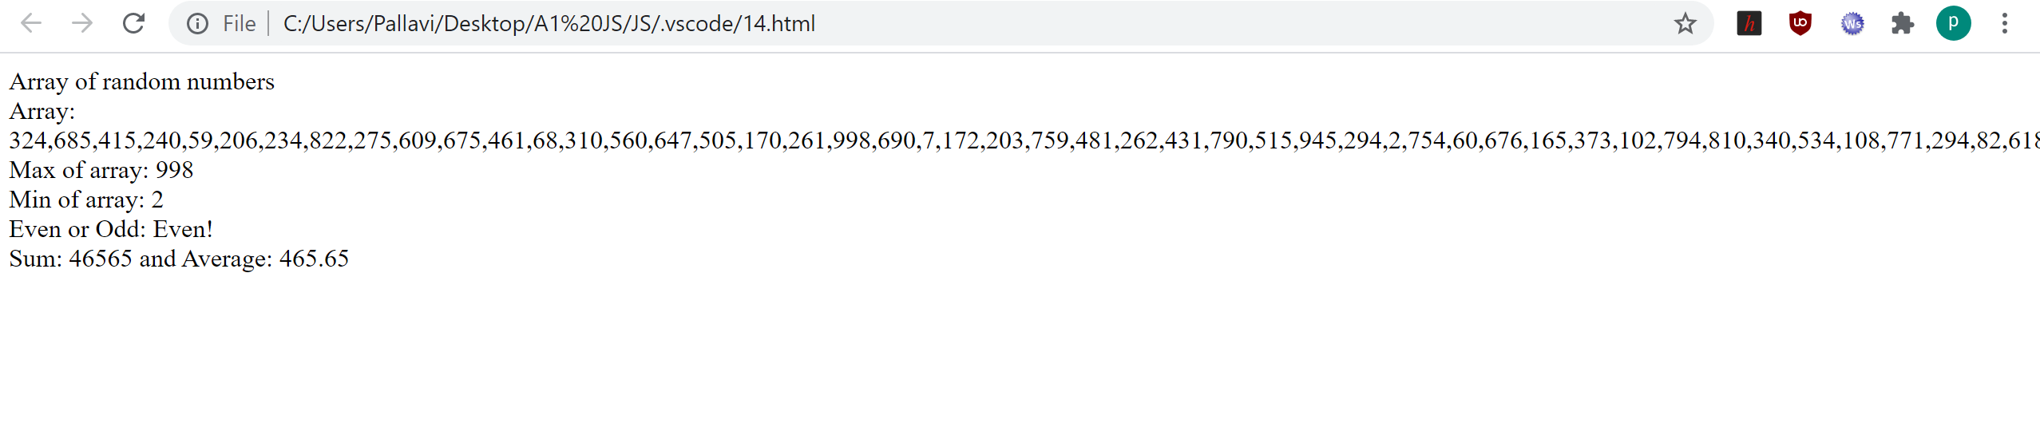
15.
<html>
<head>
<title>Sum of N numbers</title>
</head>
<body>
<script>

var array = new Array();
for (i = 0; i < 20; i++) {
array[i] = Math.floor((Math.random() * 50) + 1);
}

document.write("Array of random numbers");
document.write("<br>Array: ",array.toString());
BubbleSort(array);
Sort(array, 0, array.length-1);

function BubbleSort(arr){

for(var i = 0; i < arr.length; i++){

for(var j = 0; j < ( arr.length - i -1 ); j++){

if(arr[j] > arr[j+1]){

var temp = arr[j]
arr[j] = arr[j + 1]
arr[j+1] = temp
}
}
}
document.write("<br>sorted of array: ",arr);
}

function merge( arr, l, m, r){

var n1 = m - l + 1;
var n2 = r - m;

var L = new Array();
var R = new Array();

for (var i = 0; i < n1; ++i)
L[i] = arr[l + i];
for (var j = 0; j < n2; ++j)
R[j] = arr[m + 1 + j];

var i = 0, j = 0;

var k = l;
while (i < n1 && j < n2) {
if (L[i] <= R[j]) {
arr[k] = L[i];
i++;
}
else {
arr[k] = R[j];
j++;
}
k++;
}

while (i < n1) {
arr[k] = L[i];
i++;
k++;
}

while (j < n2) {
arr[k] = R[j];
j++;
k++;
}
document.write("<br>Merge sorted array: ",arr);
}

function Sort(arr, l, r)
{
document.write("<br> inside Merge sort");
if (l < r) {

var m =l+ (r-l)/2;

sort(arr, l, m);
sort(arr, m + 1, r);
}

merge(arr, l, m, r);
}
</script>
</body>
</html>

16.
<html>
<head>
<meta charset=utf-8 />
<title>Create a table</title>
<style>
body {
margin: 30px;
background: black;
}
#myTable{
border: 1px solid yellow;
color: white;
}
</style>
</head>
<body>
</table><form>
<input type="button" onclick="createTable()" value="Create the table">
</form>
<br><hr>
<table id="myTable" border = "1" cellspacing ="4px">
<script>
function createTable(){
rowNum = window.prompt("Input number of rows", 1);
colNum = window.prompt("Input number of columns",1);

for(var r=0;r<parseInt(rowNum,10);r++){
var x=document.getElementById('myTable').insertRow(r);
for(var c=0;c<parseInt(colNum,10);c++)
{
var y= x.insertCell(c);
y.innerHTML="Row-"+r+" Column-"+c;
}
}
}
</script>
</body>
</html>>

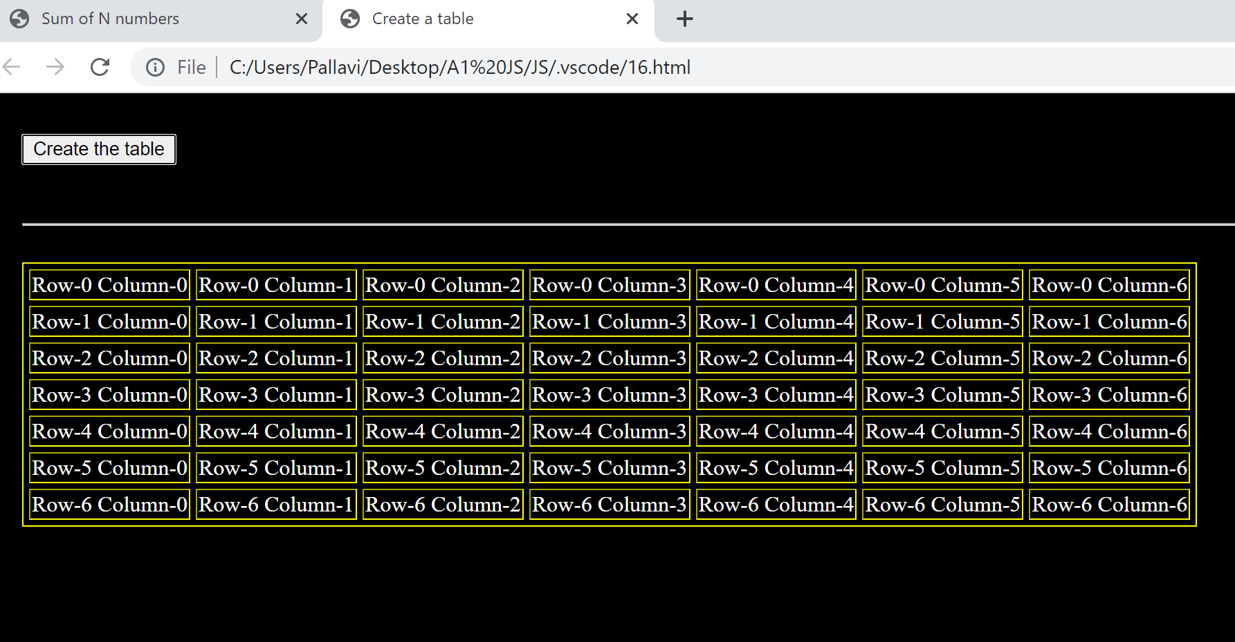

17.
<html>
<head>
<title>element rotation</title>
</head>
<body>
<script>
var array = prompt("Enter a string space seperated");
var number = parseInt(prompt("Enter no. rotations"));
array = array.split(" ");
document.write("Updated array: ",array);
while(number > 0){
array.push(array[0]);
array.shift();
document.write("<br>Updated array: ",array);
number--;
}
document.write("<br>Final array: ",array);
</script>
</body>
</html>

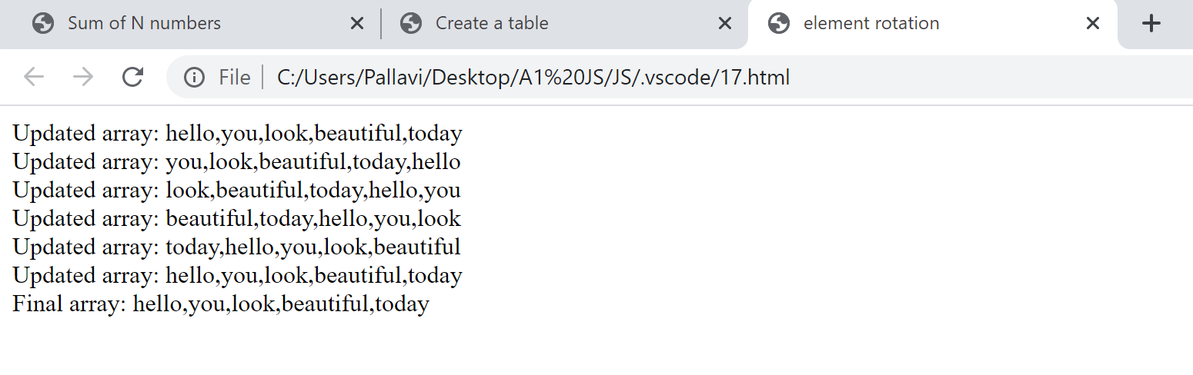
18.
<html>
<head>
<title>Pig Latin Translation</title>
</head>
<body>
<script>
var string = prompt("Enter a string: ");
document.write("Original text: ",string);
document.write("<br>Piglatin text: ",translatePigLatin(string));
function translatePigLatin(str) {
let vowels = ['a', 'e', 'i', 'o', 'u'];
let newStr = "";

if (vowels.indexOf(str[0]) > -1) {
newStr = str + "way";
return newStr;
}

else {
let firstMatch = str.match(/[aeiou]/g) || 0;
let vowel = str.indexOf(firstMatch[0]);
newStr = str.substring(vowel) + str.substring(0, vowel) + "ay";
return newStr;
}

}
</script>
</body>
</html>

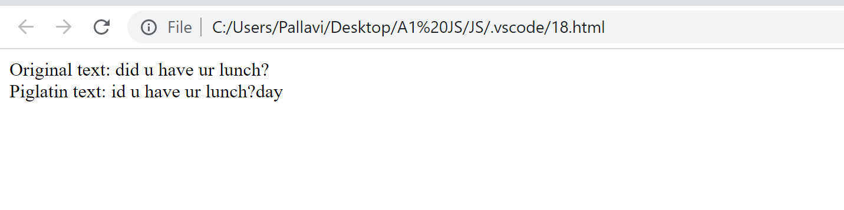
19.
<html>
<head>
<meta charset="UTF-8">
<meta name="viewport" content="width=device-width, initial-scale=1.0">
<link rel="stylesheet" href="styles.css">
<title>Calulator</title>
</head>
<body>
<div class="calculator">

<!-- disabled used to not allow users to enter numbers directly-->
<input type="text" class="display" disabled>
<div class="keys">
<div class="row">
<button value="7">7</button>
<button value="8">7</button>
<button value="9">7</button>
<button value="+" class="operator">+</button>
</div>
<div class="row">
<button value="4">4</button>
<button value="5">5</button>
<button value="6">6</button>
<button value="-" class="operator">-</button>
</div>
<div class="row">
<button value="1">1</button>
<button value="2">2</button>
<button value="3">3</button>
<button value="*" class="operator">*</button>
</div>
<div class="row">
<button value="C" class="opersator">C</button>
<button value="0">0</button>
<button value="/" class="opersator">/</button>
<button value="=" class="opersator">=</button>
</div>
</div>
</div>
<script type="javascript" src="script.js"></script>
</body>
</html>

*{
padding: 0;
margin: 0;
}

body{
width: 100vw;
height: 100vh;
overflow: hidden; /* hides scroll bar */
display: flex;
justify-content:center;
align-items: center;
background-color: #222831;
font-family: sans-serif;
}

/* calculator css*/

.calculator{
width: 300px;
padding-bottom: 15px;
border-radius: 7px;
background-color: #000;
/*
give a shadow of x-offset 5px, y-offset 8px,
blur of 8px, spread-radius of -2px and color
of black with opacity 0.61
*/
box-shadow: 5px 8px 8px -2px rgba(0,0,0,0.61);
}

/* display css*/

.display{
width: 100%;
height: 80px;
border: none;
box-sizing: border-box;
/*
The box-sizing property allows us to include the
padding and border in an element's total width
and height.
*/
padding: 10px;
font-size: 2rem;
background-color: #00ff44;
color: #000;
text-align: right;
border-top-left-radius: 7px;
/*
rounds the top-right corner of an element by
specifying the radius (or the radius of the
semi-major and semi-minor axes) of the ellipse
defining the curvature of the corner.
*/
border-top-right-radius: 7px;
}

/* row css */

.row{
display: flex;
/*
The justify-content property aligns the flexible
container's items when the items do not use all
available space on the main-axis (horizontally).
*/
justify-content: space-between;
}

/* button css */

button{
width: 50px;
height: 50px;
border-radius: 50%;
border: none;
outline: none;
/*
The rem unit sets the font-size relative to the
browsers base font-size, and will not inherit from
its parents.
*/
font-size: 1.5rem;
background-color: #222;
color:#fff;
margin: 10px;
}
button:hover{
/*
used to change the mouse cursor to pointer
*/
cursor: pointer;
}

/* operator */

.operator{
background-color: #00ff44;
color:#000;
}

// select all the buttons
const buttons = document.getElementsByTagName('button');

// select the display element
const display = document.getElementsByClassName("display");

// add eventListener to each button
buttons.forEach(
function(button){
button.addEventListener('click',calculate);
}
)

/*
forEach loop will loop through each <button> element inside
buttons array and for each element, it activates the inner function.

The inner function takes each button and attaches a 'click'
event listener. If it detects any 'click' event, then it calls
the calculate function.
*/

/* Calculate function */

function calculate(event){
// current clicked buttons value
const clickedButtonValue = event.target.value;

if(clickedButtonValue == "="){
// check if display is not empty then calculate and show answer
if(display.value != "")
display.value = eval(display.value);
}
else if(clickedButtonValue === "C")
display.value ="";
else{
// concatenate it to display
display.value += clickedButtonValue;
}
}

/*
The calculate function automatically gets the event object as its
first argument. The event object is simple.
*/

